Lincoln Mountain Open Space

This information applies to all pack walks scheduled for Lincoln Mnt Open Space.

All pack walks begin at 7AM.

Lincoln Mountain Open Space is a little more wild than your average dog park. It has tall (scratchy) grass and bugs. Please see below for recommendations on what to bring. This is the best location to hold a pack walk, no fees, no other dogs, and tons of space!!!

SPECIAL CONSIDERATIONS: Ideally you should treat your dog with a flea and tick repellant prior to this pack walk. Just to be on the safe side, there are a lot of deer in this area and ticks can be picked up from the vegetation. Humans, please take you allergy meds prior to the pack walk.

Things to bring (Human Packing List)
- Pants! No shorts please, the grass will irritate your skin!!!
- Deet free bug spray and sunblock (there are biting flies in some areas)
- Comfortable closed-toed walking shoes, NO SANDALS! There are weeds that are thorny!
- Snacks, blanket, small trash bag and other commodities for a picnic, (make sure you can carry everything in a backpack or bag)
- Water

Things to bring (Doggy Packing List)
- Doggy snacks
- Doggy bowl
- Towel(s) (there is a creek and a pond and your dog will likely get wet.)
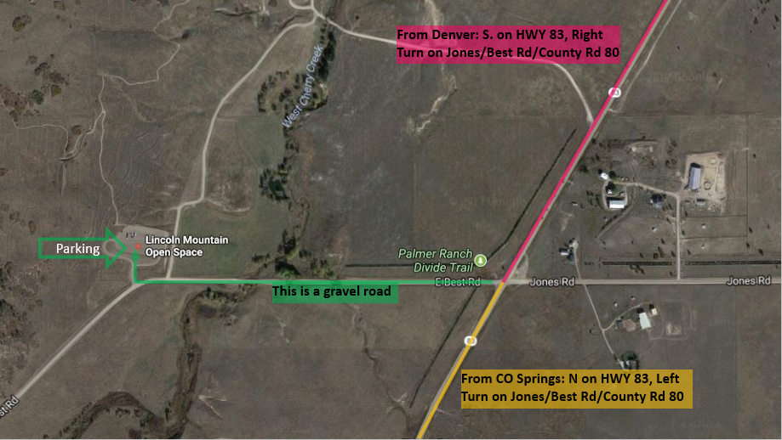
- Leash
​
Directions: From Denver or coming from the north.
If you google “Lincoln Mountain Open Space” the directions will take you miles down a gravel, if your vehicle can handle it, this is the fastest way, if not, take HWY 83 south and make a right on Best Rd/Jones Rd/County Road 80 (the road has many names and it is a gravel road). Drive approx. ¼ mile and you will see the parking area on the right-hand side.

Directions: From Colorado Springs or coming from the south.
You can google “Lincoln Mountain Open Space” and follow those directions or go north on HWY 83 and make a left on Best Rd/Jones Rd/County Road 80 (the road has many names and it is a gravel road). Drive approx. ¼ mile and you will see the parking area on the right-hand side.

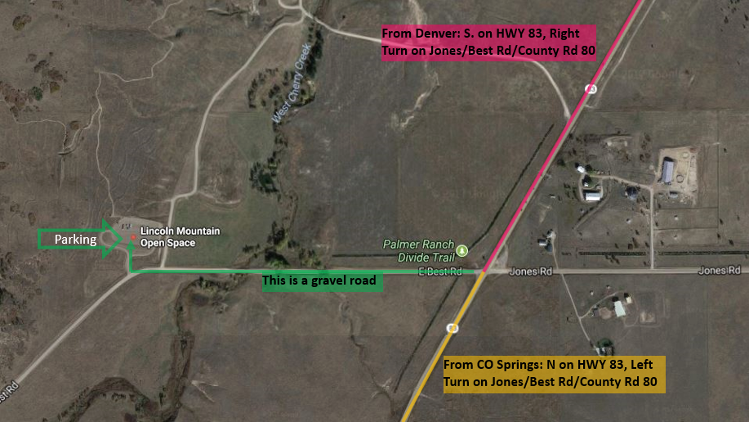

At the dog park, if you do not see any Northern Inuits in the parking lot and it is past 7AM call us @ 719-373-0696 we will send someone to fetch ya!

