Cherry Creek Dog Park

This information applies to all pack walks scheduled for Cherry Creek Dog Park.

All pack walks begin at 7AM.

Remember, Cherry Creek Dog Park is on a state park and there is a small entry fee for the State Park and the Dog Park visit http://cpw.state.co.us/off-leash-cc for more details.

Things to bring:
- A jacket or sweater. It will be perfect Nit Wit weather!
- Water (for you and your dog)
- Doggy snacks
- Doggy bowl
- Towel(s) (there is a creek at the dog park and your dog will likely get wet. The dogs will go into the mud hole but they will wash off when we get to the creek)
- Comfortable walking shoes (waterproof if possible or bring an extra pair in case your shoes get wet)
- Leash
- Cash (for entry fee)
- Wear your NISA shirt if you have one!
NOTE: YOUR DOG WILL GET WET!!! YOU MIGHT ALSO, COME PREPARED!
​
Directions:
To get to Cherry Creek Dog Park: From the intersection of Parker Road (CO-83) and Orchard Rd, head west (if you are southbound on Parker road make a right, northbound make a left on Orchard. Once on Orchard Rd, make a right at S. Entrance Road. You will see a small shack where you pay your entry fee.
REMEMBER: Typing "Cherry Creek Park" into your GPS will take you to the state park and not the dog park. The dog park doesn't have an address so the coordinates are 39.613145, -104.815566. You can also google "Cherry Creek Dog Park" and use google maps to get there on your phone.

At the dog park, if you do not see any Northern Inuits in the parking lot and it is past 7AM call us @ 719-373-0696 . We will be taking the long way to the creek by following the trail to the right-hand side after entering the park. (See the pink trail line on the map).
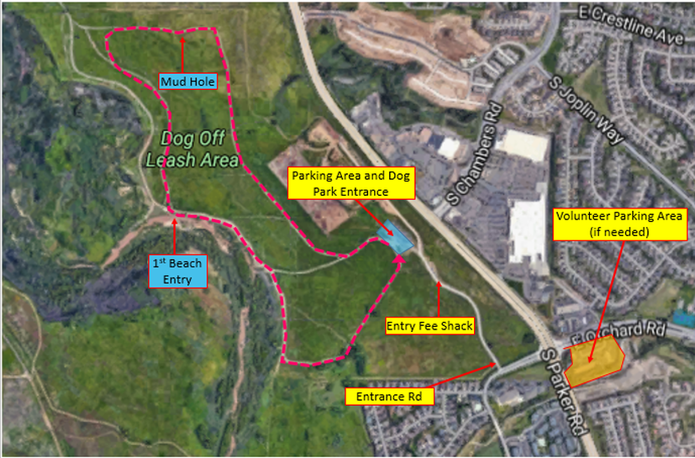

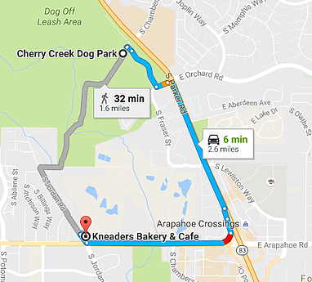
After the pack walk we will go to Kneaders:
Address: 14455 E Arapahoe Rd, Aurora, CO 80016
Directions: From the dog park, head south on Parker Road. Take the Arapahoe Rd exit and make a right to get on Arapahoe Rd. Make a right on Jordan Road and Kneaders will be on your right hand side.

